Java throw exception->

The Java throw keyword is used to explicitly throw an exception.

We can throw either checked or uncheked exception in java by throw keyword.

The throw keyword is mainly used to throw custom exception. We will see custom exceptions later.

**The syntax of java throw keyword is given below.->**

1. **throw** exception;

**->**

**throw** **new** IOException("sorry device error);

## **java throw keyword example->**

In this example, we have created the validate method that takes integer value as a parameter. If the age is less than 18, we are throwing the ArithmeticException otherwise print a message welcome to vote.

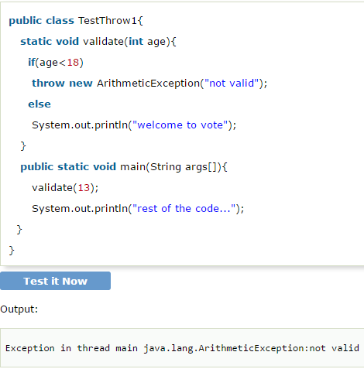

# Java Exception propagation->

|  |
| --- |
| An exception is first thrown from the top of the stack and if it is not caught,  it drops down the call stack to the previous method,If not caught there, the exception again drops down to the previous method,  and so on until they are caught or until they reach the very bottom of the call stack.This is called exception propagation. Rule: By default Unchecked Exceptions are forwarded in calling chain (propagated) |

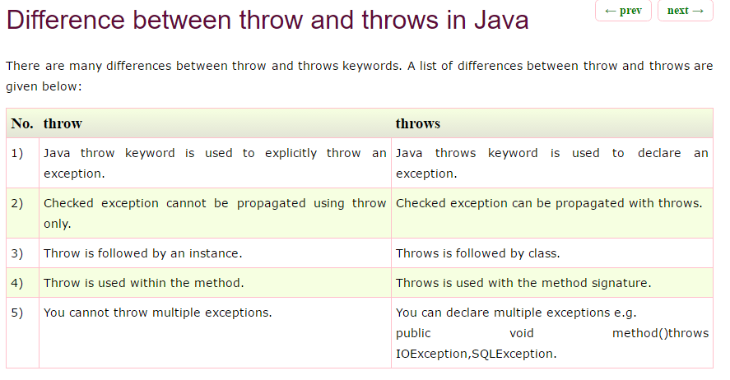

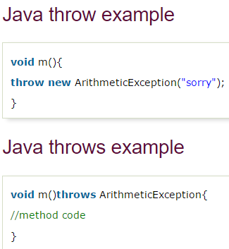

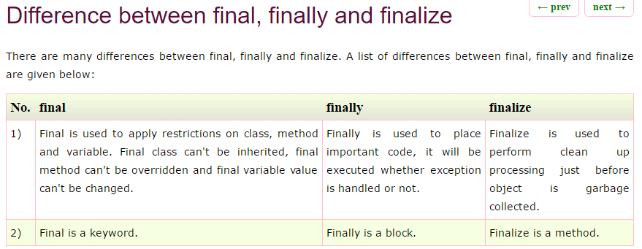

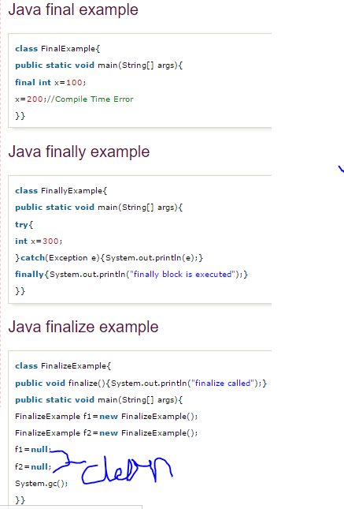s